# **Why Business Intelligence Important ??**

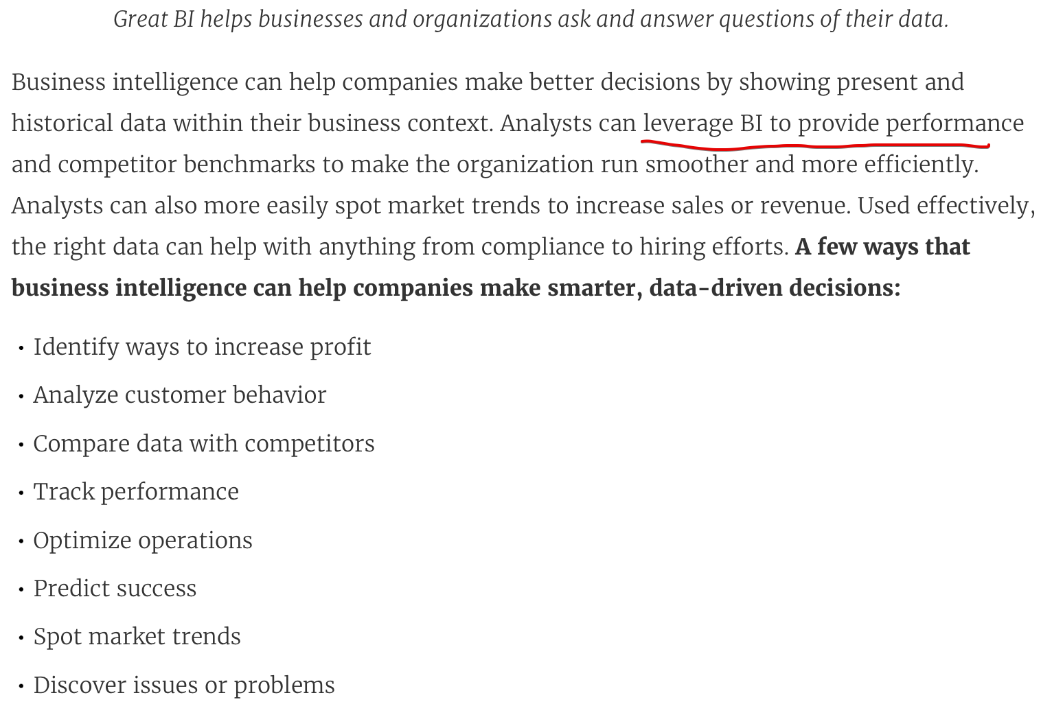

# **Business Intelligence vs Business Analytics**

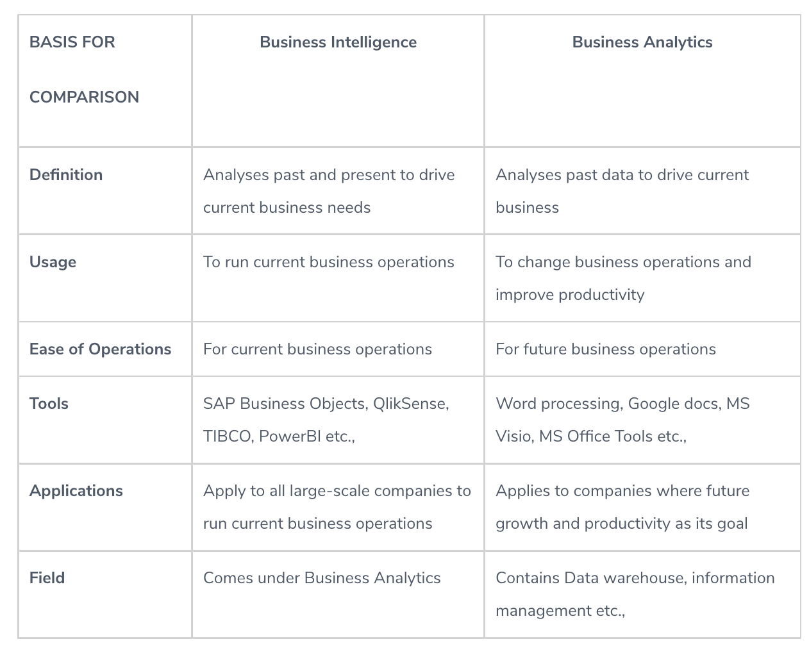

<https://www.educba.com/business-intelligence-vs-business-analytics/>

# **Traditional BI vs Modern BI**

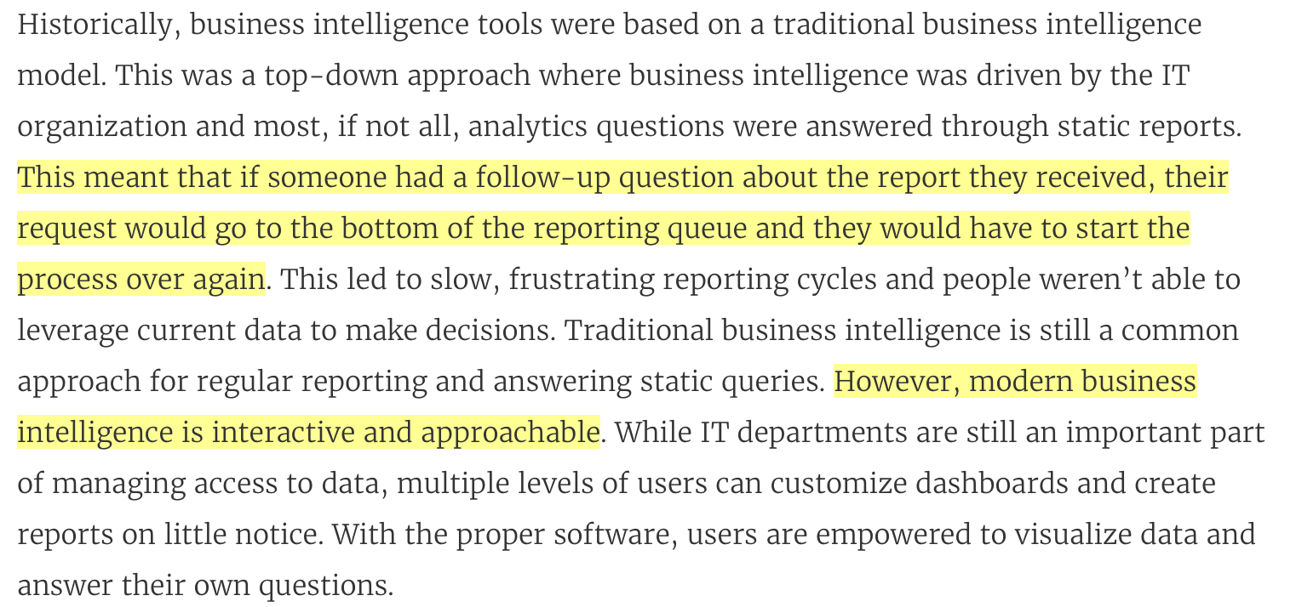

# **Primary objectives of Business Intelligence**

* 1. Business Intelligence is leverage to make the following enterprise-level decisions.
  2. Business Intelligence helps in identifying the wrong tracks and approaches of a business.
  3. Business Intelligence can cluster the data for analysis and then compile them to monitor corrective actions.
  4. Business Intelligence is also useful for determining whether a company is executing as per plan.
  5. Identification and extraction of trends and insights from business are possible using Business Intelligence tools.

# **Characteristics of Data warehouse**

* 1. A data warehouse is a separate database responsible for storing historical information records and is kept separate from an operational database.
  2. Processed and analysed data from a data warehouse helps make top management strategic and tactical decisions based on the analysis.
  3. Analysing data in the data warehouse helps the business analysts and users see the current business trends.
  4. The data warehouse is also responsible for consolidating historical data analysis.

**BI Project Life Cycle**

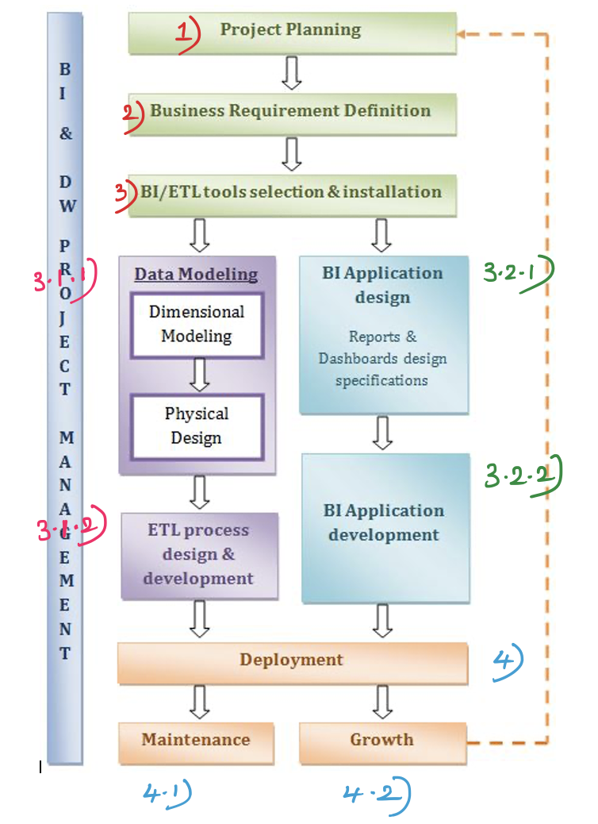

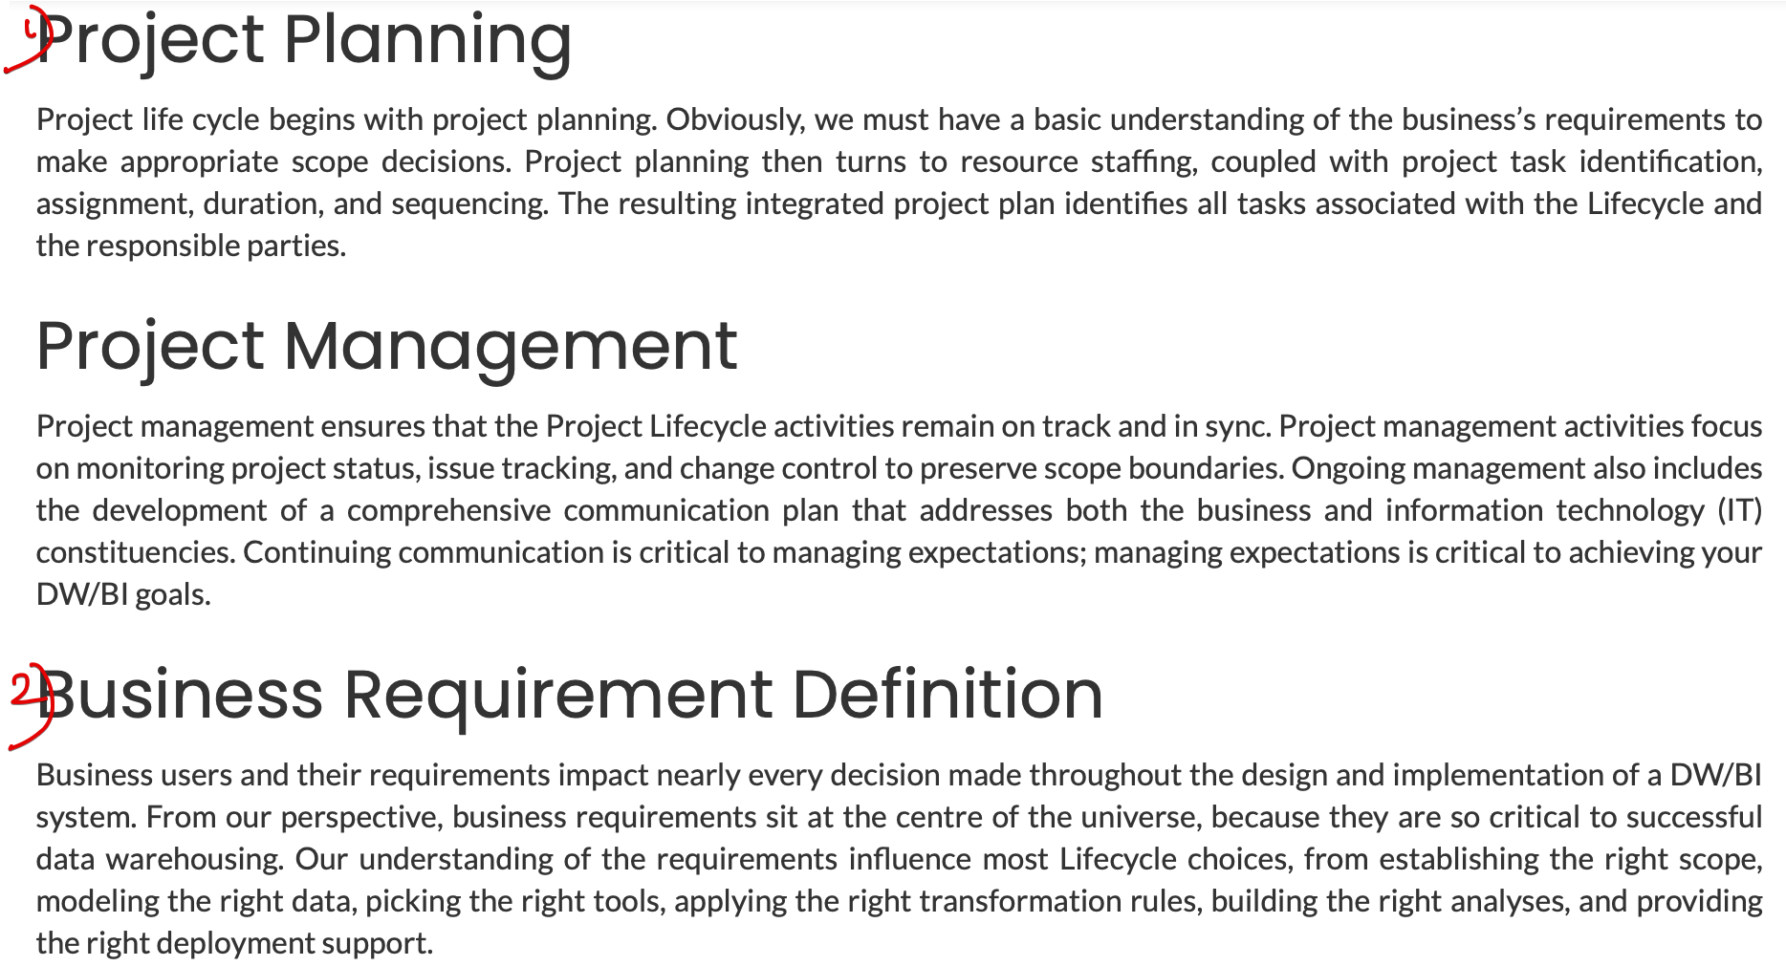

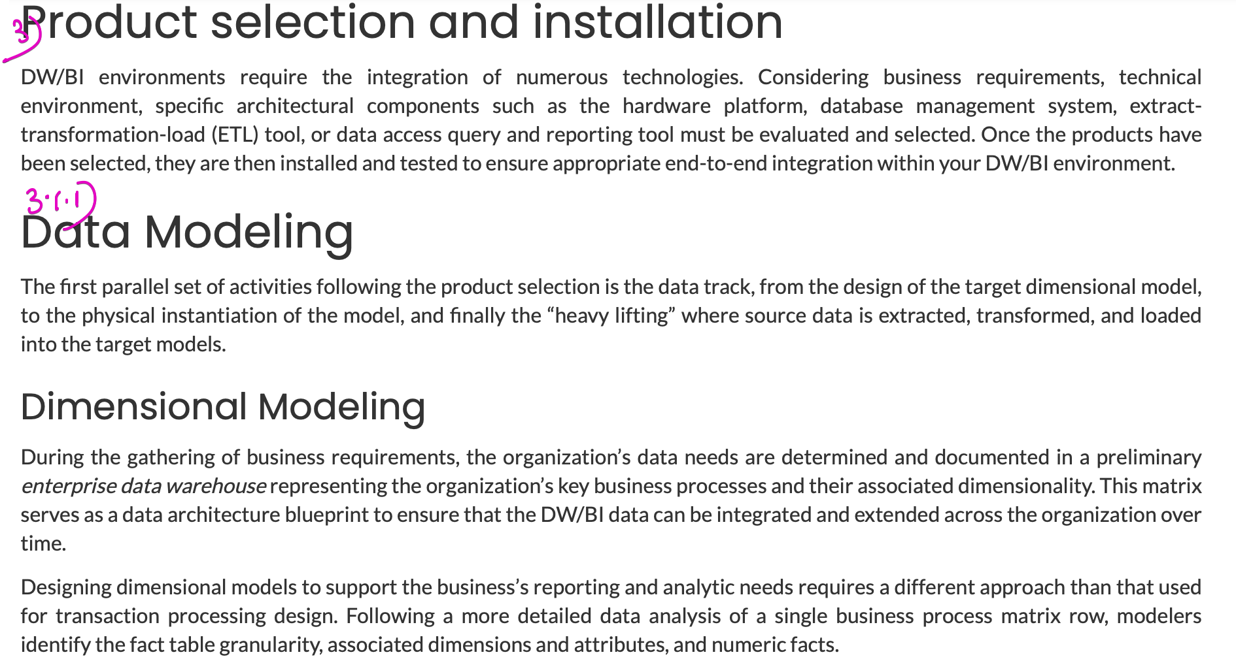

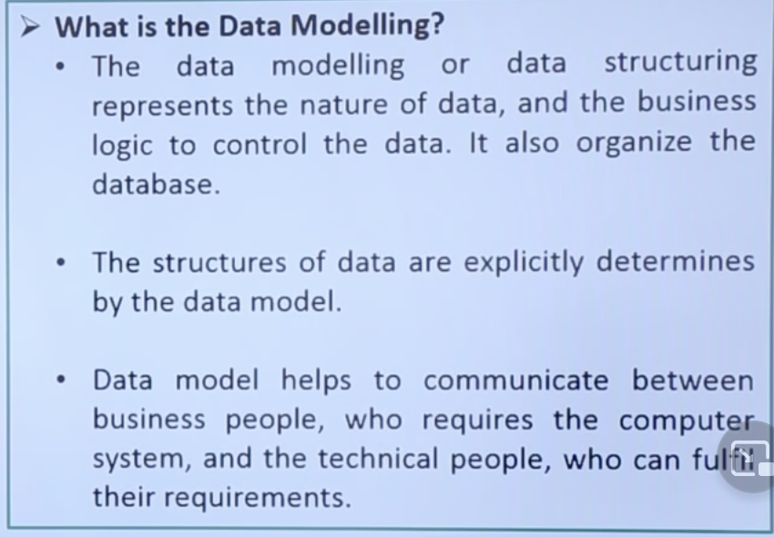

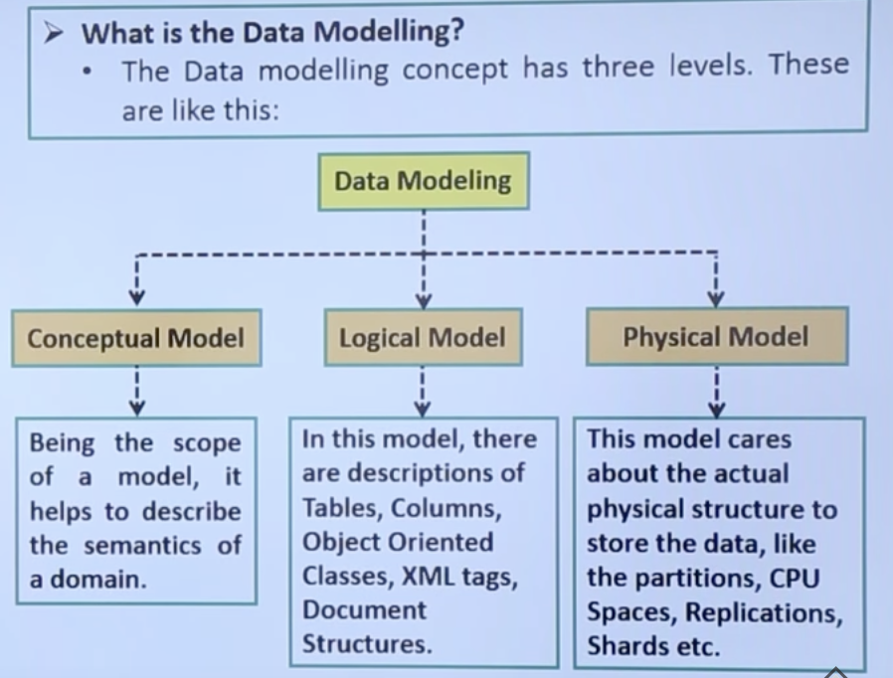

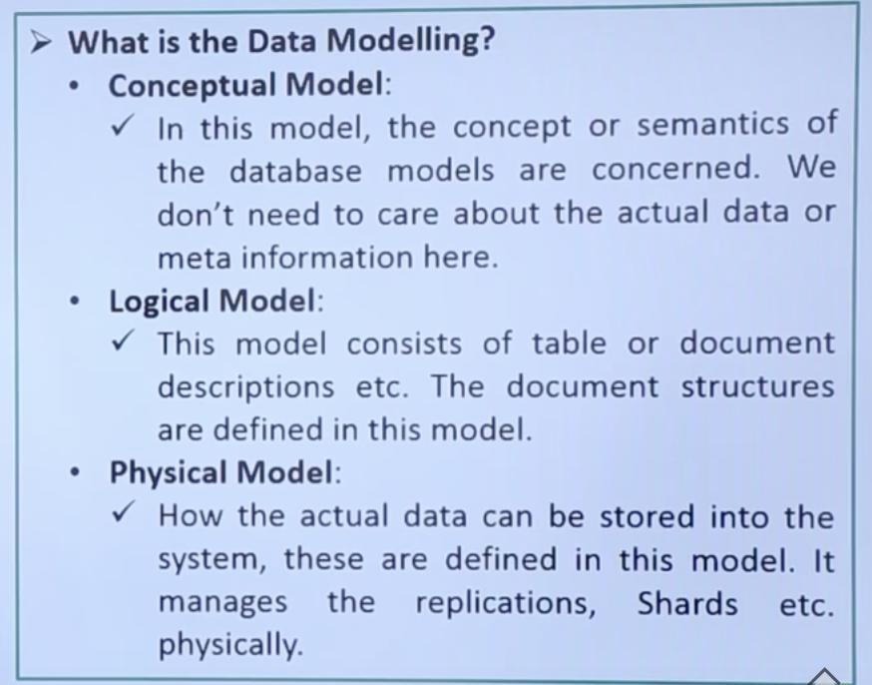

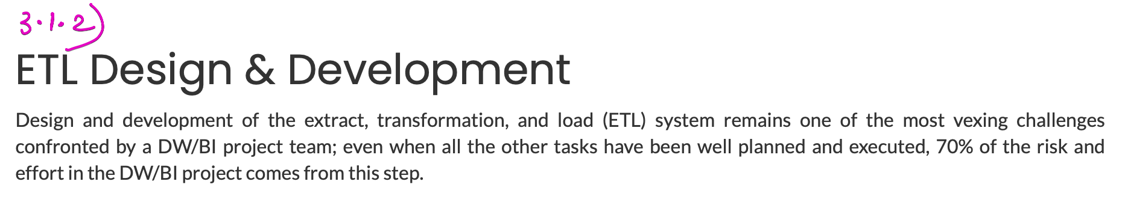

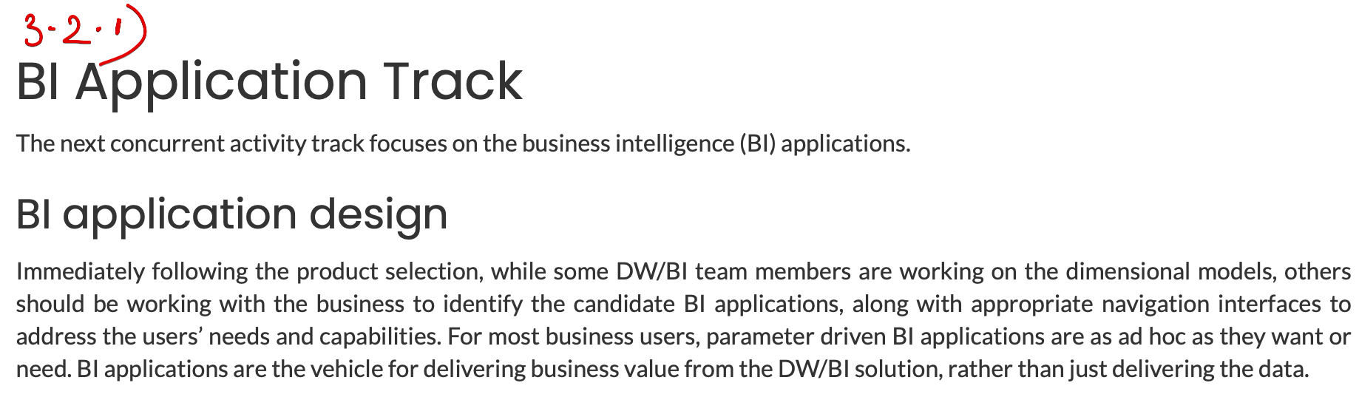

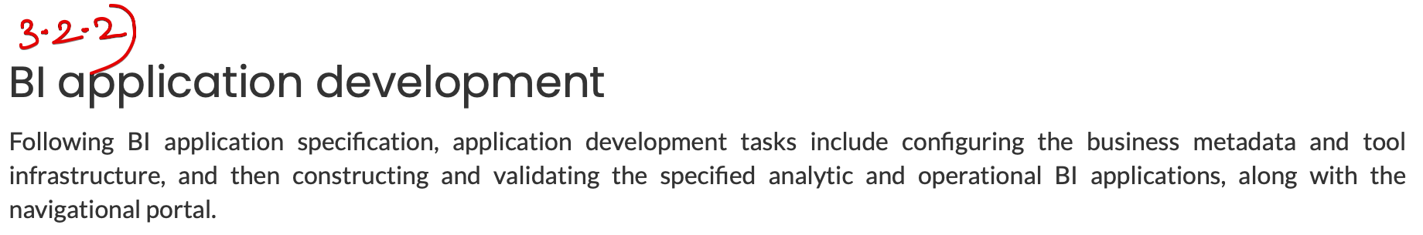

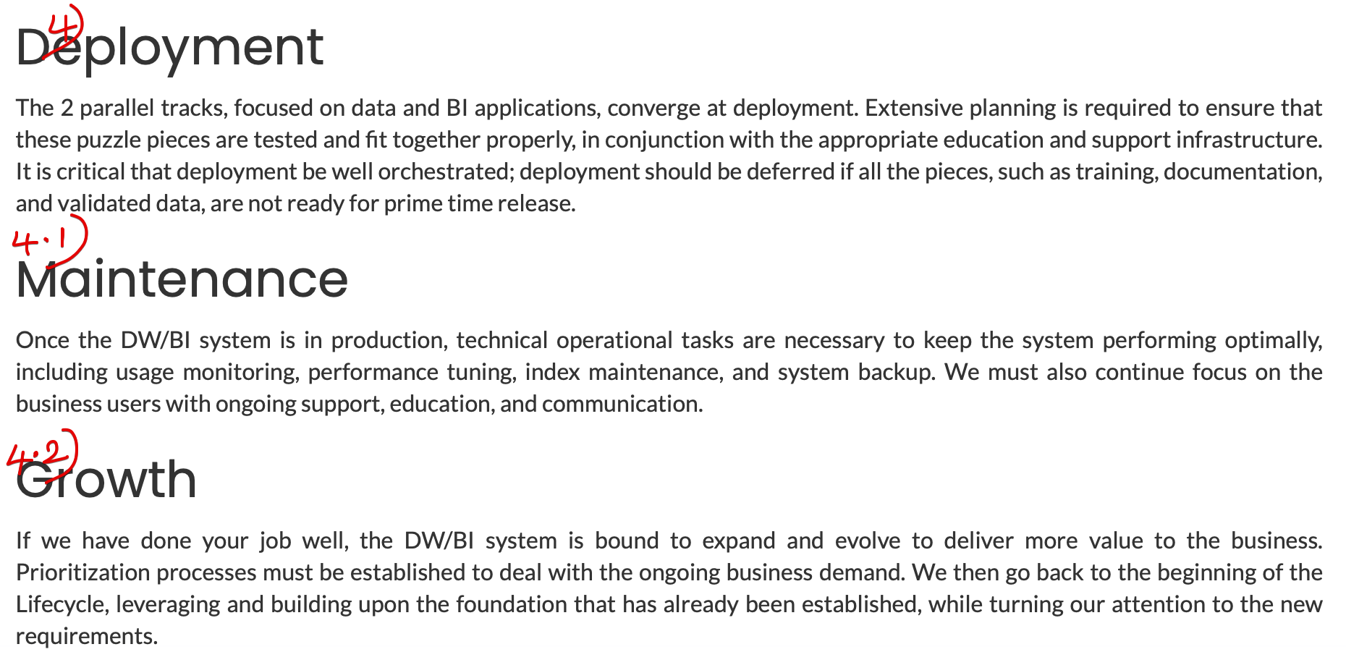

**Parallel Development Tracks**

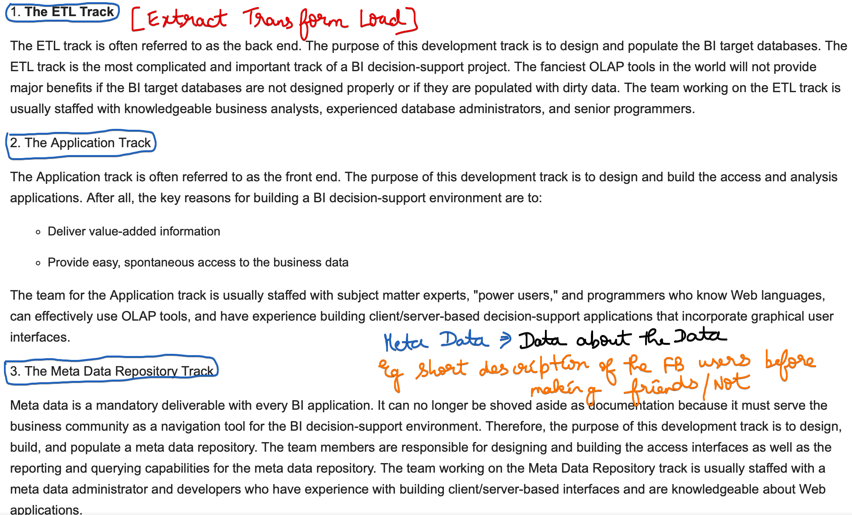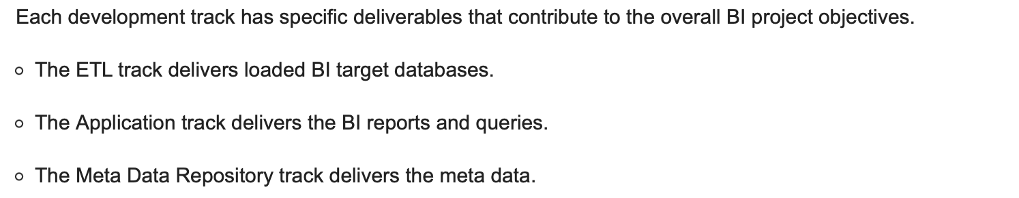

**A Successful BI Strategy**

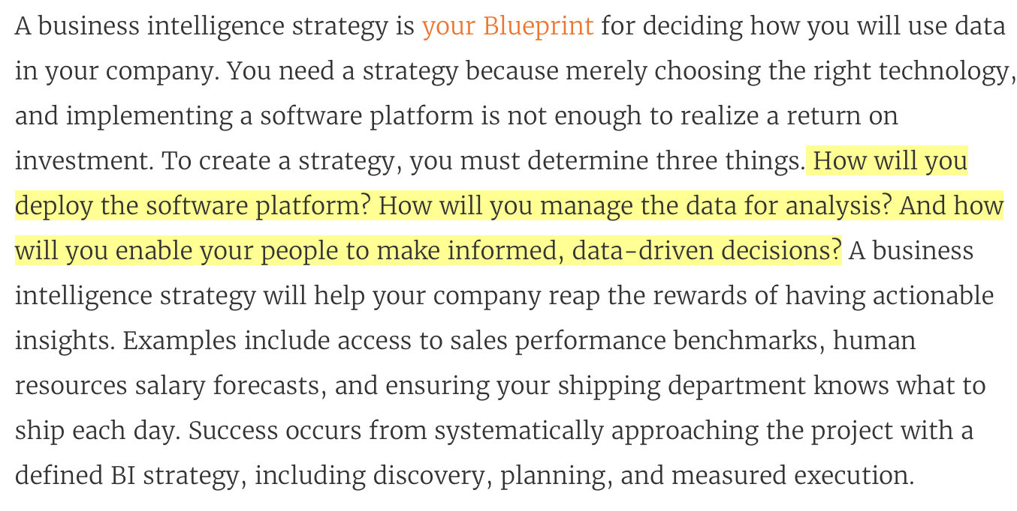

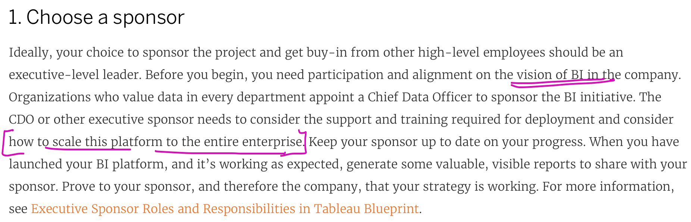

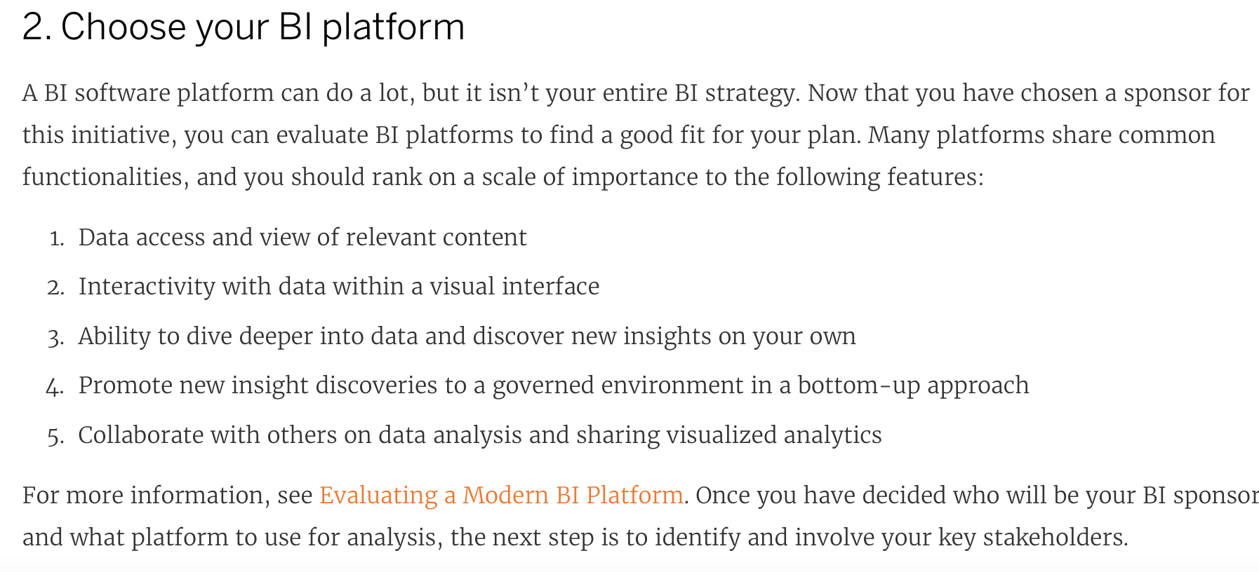

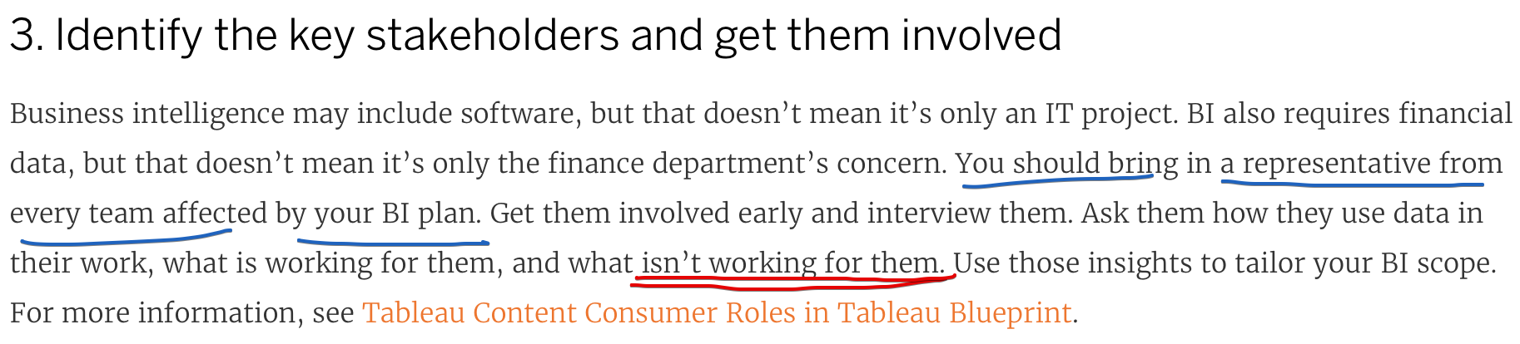

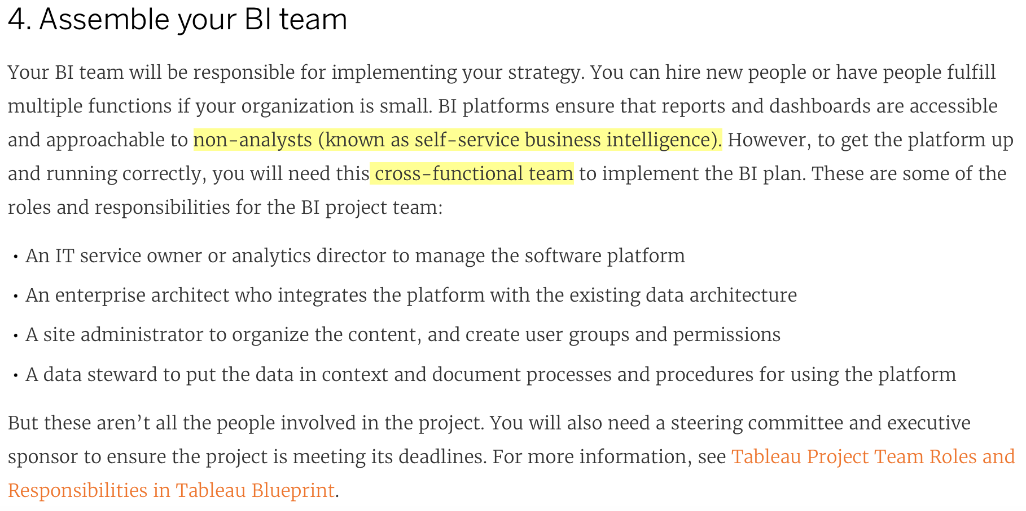

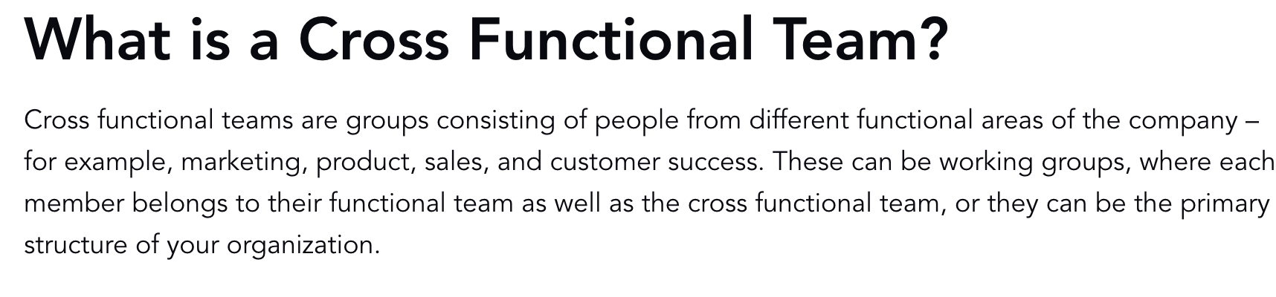

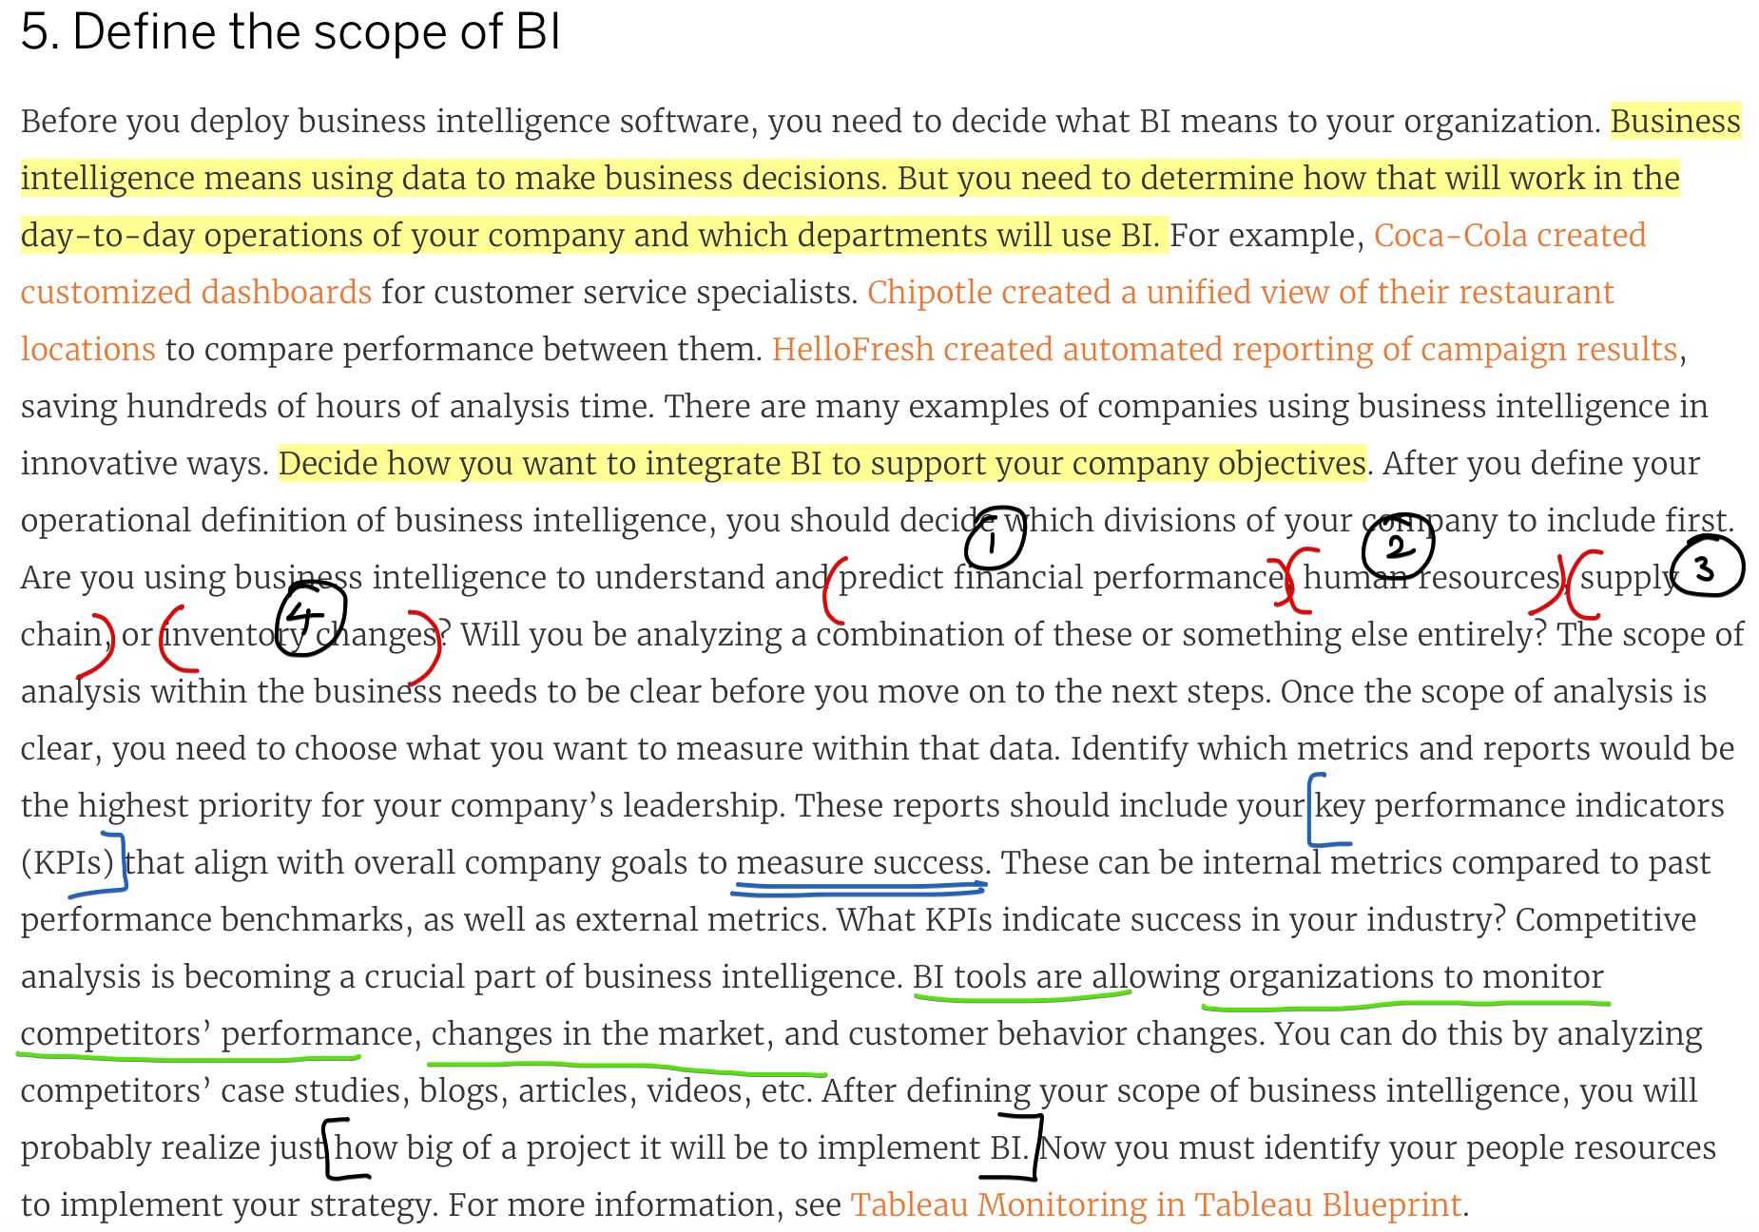

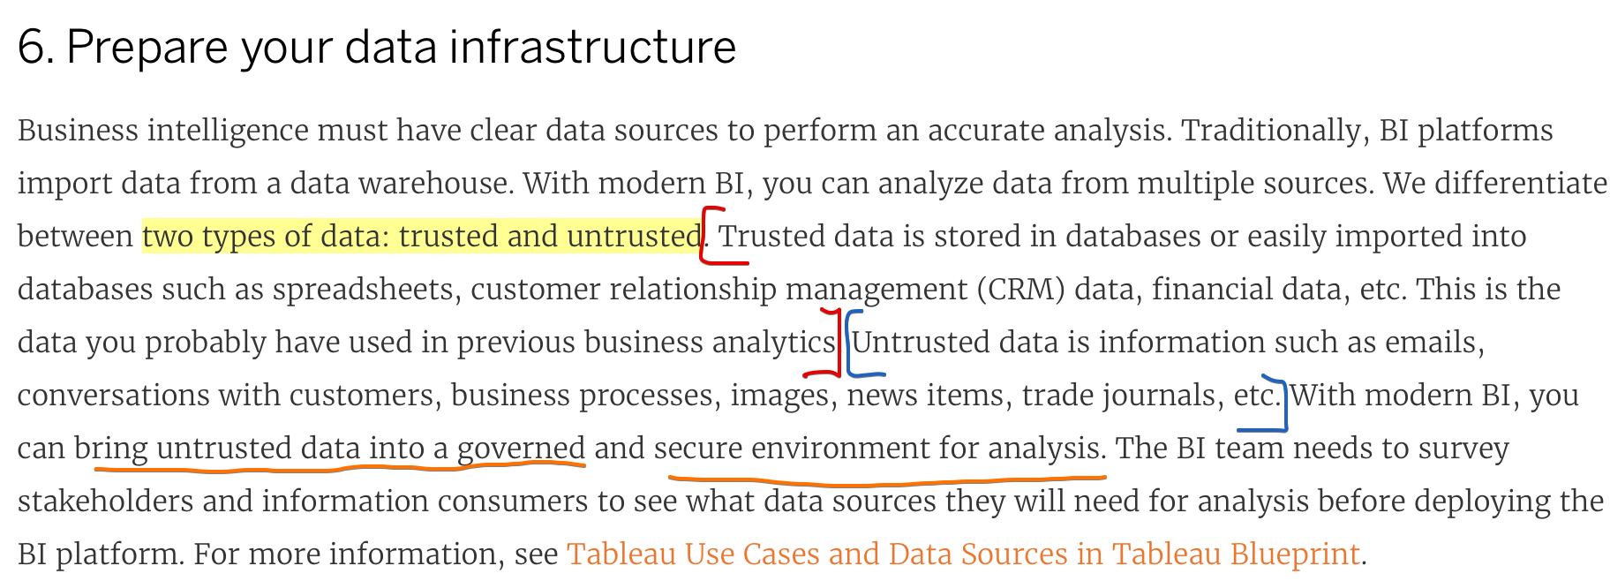

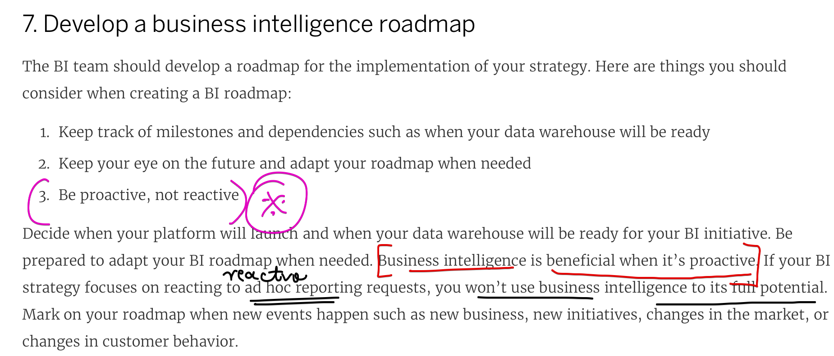

# **Technical Review**

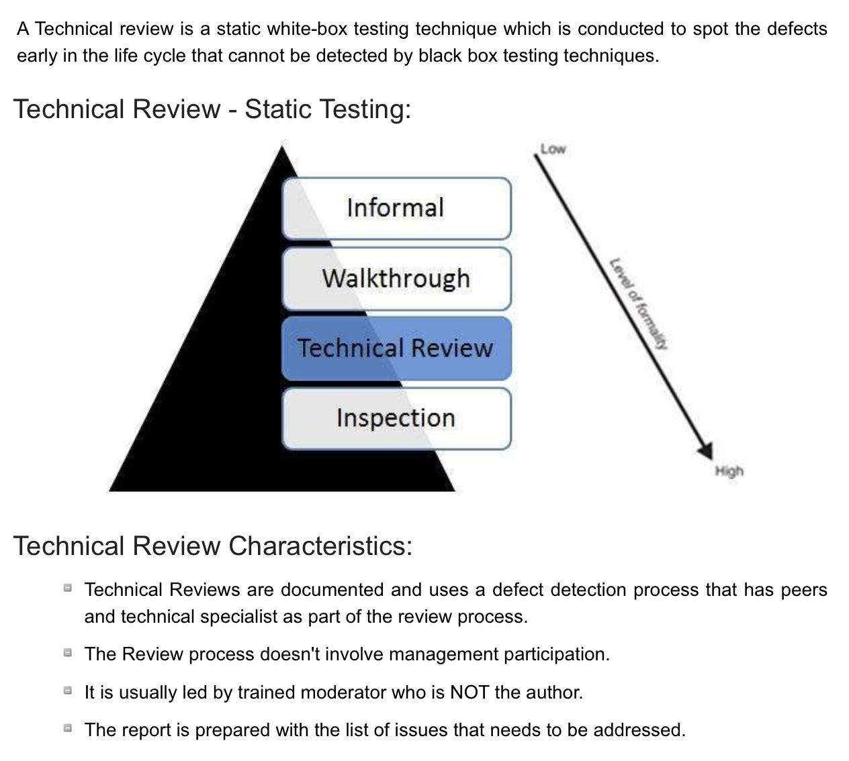

# **Terminologies**

## **KPI 🡪 Key Performance Indicator**

Key Performance Indicators (KPIs) are the critical (key) indicators of progress toward an intended result. KPIs provides a focus for strategic and operational improvement, create an analytical basis for decision making and help focus attention on what matters most. As Peter Drucker famously said, “What gets measured gets done.”  
  
Managing with the use of KPIs includes setting **targets** (the desired level of performance) and tracking progress against that target. Managing with KPIs often means working to improve**leading indicators** that will later drive lagging benefits.

**Leading indicators**  are precursors of future success;  
**Lagging indicators** show how successful the organization was at achieving results in the past.

From  250 lbs / 113 kg to  185 lbs / 84 kg, the entire process in achieving the goal.

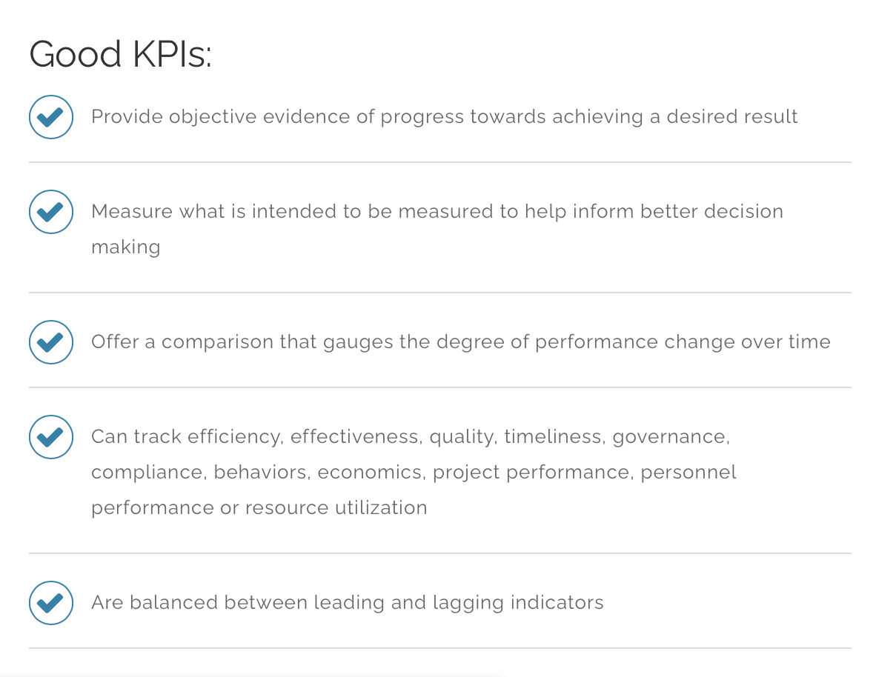

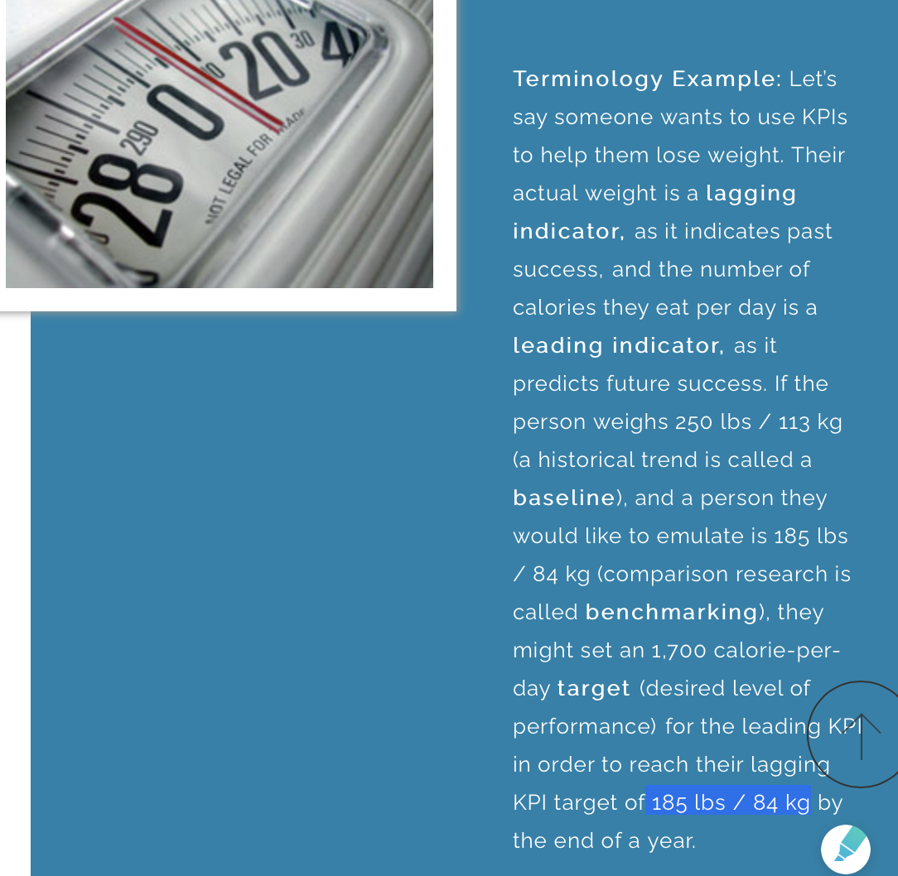

## **Meta Data**

<https://www.youtube.com/watch?v=fZWg0ClQkYQ>

# **Advantages and Disadvantages of BI**

**Advantages of using BI systems are:**

* 1. It helps boost productivity and makes it possible to create a business report with just a single click.
  2. It also helps increase the visibility of the data analysis and possibly identify those areas that demand attention.
  3. As per the organization’s goals, the BI system sets the accountability.
  4. BI systems automate several tasks by offering predictive analysis, benchmarking, modelling figures, and statistical calculations using different methodologies.

**Disadvantages of Business Intelligence Systems are:**

* 1. The BI systems are costly, so using them for small and medium scale enterprises will prove expensive.
  2. Implementing BI systems for the data warehouse is complicated. Hence, the complexity of using it is another drawback of it.

# **Case-Studies**

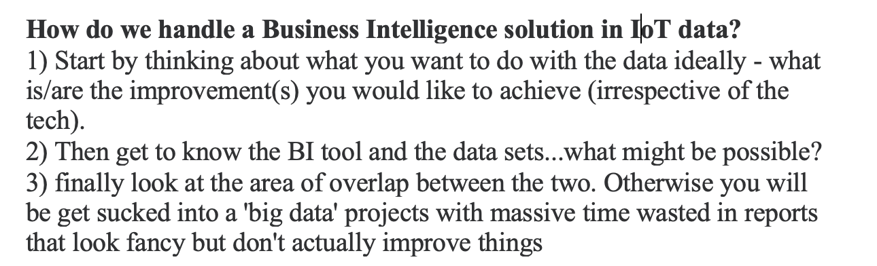

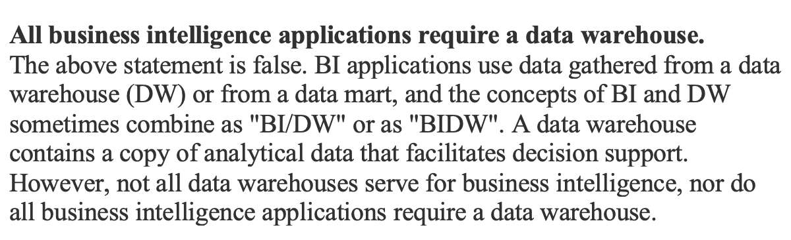

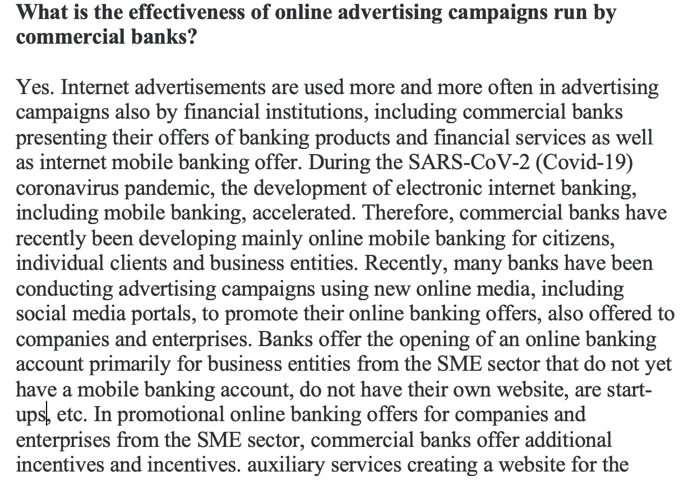  
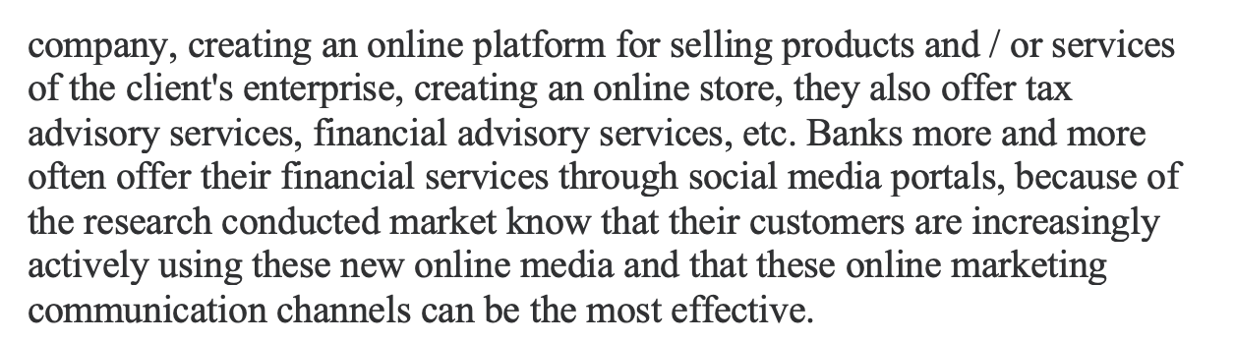

# **BI strategy:**

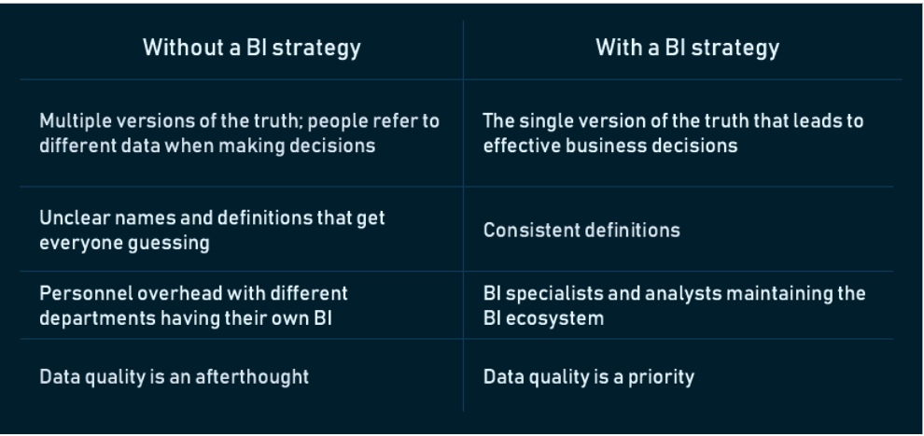

Your BI strategy has three main elements:

**Vision**. Why are you building the BI practice in your company and what do you want to achieve?

**People and processes**. Who will define and run the BI strategy? And how?

**Tools and architecture**. Which dashboards and solutions do we want to build? For which areas? And how will they impact those areas?

**Step 0. Assess your current BI ecosystem**

So, the first thing to do is **talk to all players of the current BI processes**: users and the IT team, department managers and stakeholders. As a result, you should have answers to the following questions:

* What’s your BI vision and or do you have any? How is that vision aligned with your IT and corporate strategy?
* Who are your BI players and how coordinated are they? Is there function overlap?
* How do you handle data management and data governance? How do you support BI users?
* What solutions are you using and how? Which of them bring value?
* Is your architecture aligned with corporate strategy? Are you sure that your licensing model works best?

## **Step 1. Create the vision**

A **vision** is a combination of purpose and direction. There’s no strategy without a vision. It manifests itself in the form of many crucial decisions, like what data we will be sourcing or who will get access to the insights.

A vision also has a very mundane purpose: explaining to people in your organization — who already have their favourite tools and processes — why they need new ones, and how the transformation will happen.

**BI Maturity model** – the scale that tells you how mature your strategy is.

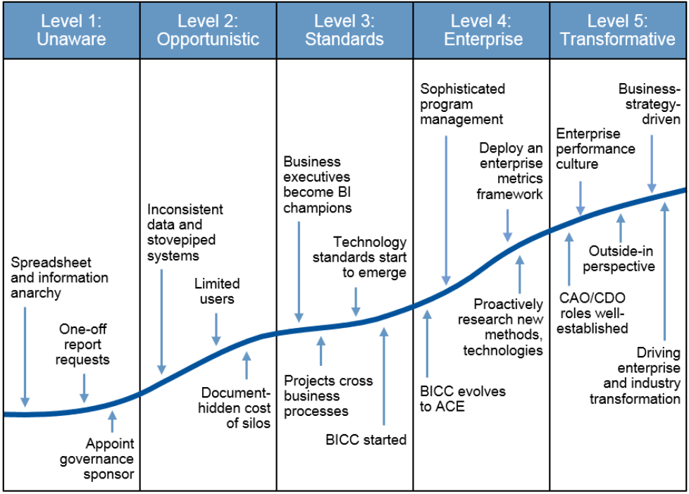

## **Step 2. Establish BI governance processes**

* A **BI governance team** or people who will be responsible for governance processes
* **BI tools and lifecycle management** or the design and development of BI architecture
* **User support** from technical, functional, and data standpoints

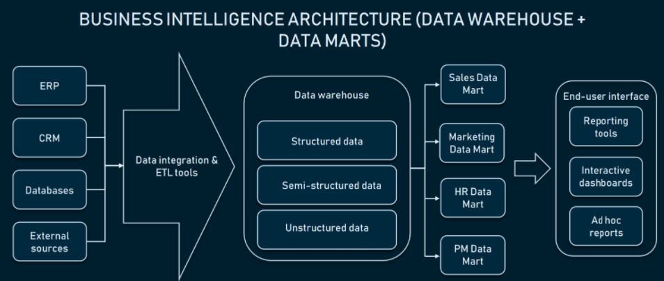

Choosing BI tools, Drafting the data integration process, Ensuring data presentation, Performing user acceptance tests, Performing training.

**User Support:** Data education support(Metadata, data purpose, metrics, Data source), Tool support, Business support.

## **Step 3. Build a BI roadmap**

Here, a roadmap is a visual document demonstrating deliverables at different stages of implementation within the timeline. By this step, you already have all the data you need to organize and schedule on the map, you only need to set up time frames and deliverables for every task.

## **Step 4. Document a BI strategy**

The logic behind a strategy document is that it will be a point of reference for the whole organization and will be used for the strategy presentation. What sections should go into this document?

1. **Executive summary**. Written last but included in the very beginning, the summary gives an overview of steps and advancements you’re planning to make to reach your strategic goals. Why you’re starting this process, what your vision is, the timeframe, and deliverables.
2. **BI strategy alignment with corporate strategy.** Go into detail about the value BI will bring to the organization, what problems it will solve, and how new processes will support the existing ones.
3. **Project scope and requirements**. This is the place for your roadmap and BI architecture schema, where you go into detail about best vendors, architecture design, required staff and budget. Basically, explain the next steps after the strategy document is shared/presented.
4. **BI governance team**. Let the audience meet the group responsible for the effort and communicate to end users who their immediate managers are.
5. **Alternatives**. Here, review the options you’ve considered but chose to pass on and explain why they didn’t work. This will reduce the audience’s doubt and highlight the benefits of the final decisions.
6. **Assessment**. Explain deliverables and the metrics of success you will be calculating. For example, end users must know why you’re reaching out for feedback or tracking their activity in the system.
7. **Appendices**. Lastly, provide additional information like the list of picked vendors, organization charts, a glossary of terms, and even a corporate strategy document to revisit and compare.

## **Step 5. Review your BI strategy every year**

* How will you measure the success of your BI strategy? Quantitative metrics alone won’t do – you want to know how much better you understand your business or even how strong end users’ relationships have become.
* You can **revisit your BI Maturity model** to determine whether you’re going in the right direction and establish metrics. The main one would be ROI, which describes if BI actually brought expected value.
* **Qualitative metrics** would include things like the number of data access requests made by end users, increased productivity, or that deadlines are met more often.
* You should also measure the **effectiveness of the BI governance group** – whether all goals were met and if the priorities haven’t shifted.